**WA2U USING PYTHON**

**SYSTEM DOCUMENTATION**

28th Aug 2019  
  
  
  
Prepare By,  
Van Tze Shan

### IMPORTANT NOTICE

### ALL RIGHTS RESERVED

Software and documentation are the confidential property and contain the trade secrets of

Prestige Atlantic Asia Sdn Bhd

1-2, Jalan 5/125D, Taman Desa Petaling

57100 Kuala Lumpur

Malaysia

Tel: 603-90573428 Fax: 603-90575088

e-mail: [support@prestigeatlantic.com.my](mailto:support@prestigeatlantic.com.my)

website: [www.prestigeatlantic.com.my](http://www.prestigeatlantic.com.my)

Any copying, use, disclosure, modification, transfer or otherwise must have written consent from

Prestige Atlantic Asia Sdn Bhd

### IMPORTANT NOTICE

### ALL RIGHTS RESERVED

Software and documentation are the confidential property and contain the trade secrets of

Prestige Atlantic Asia Sdn Bhd

1-2, Jalan 5/125D, Taman Desa Petaling

57100 Kuala Lumpur

Malaysia

Tel: 603-90573428 Fax: 603-90575088

e-mail: [support@prestigeatlantic.com.my](mailto:support@prestigeatlantic.com.my)

website: [www.prestigeatlantic.com.my](http://www.prestigeatlantic.com.my)

Any copying, use, disclosure, modification, transfer or otherwise must have written consent from

Prestige Atlantic Asia Sdn Bhd

### IMPORTANT NOTICE

### ALL RIGHTS RESERVED

Software and documentation are the confidential property and contain the trade secrets of

Prestige Atlantic Asia Sdn Bhd

1-2, Jalan 5/125D, Taman Desa Petaling

57100 Kuala Lumpur

Malaysia

Tel: 603-90573428 Fax: 603-90575088

e-mail: [support@prestigeatlantic.com.my](mailto:support@prestigeatlantic.com.my)

website: [www.prestigeatlantic.com.my](http://www.prestigeatlantic.com.my)

Any copying, use, disclosure, modification, transfer or otherwise must have written consent from

Prestige Atlantic Asia Sdn Bhd

### IMPORTANT NOTICE

### ALL RIGHTS RESERVED

Software and documentation are the confidential property and contain the trade secrets of

Prestige Atlantic Asia Sdn Bhd

1-2, Jalan 5/125D, Taman Desa Petaling

57100 Kuala Lumpur

Malaysia

Tel: 603-90573428 Fax: 603-90575088

e-mail: [support@prestigeatlantic.com.my](mailto:support@prestigeatlantic.com.my)

website: [www.prestigeatlantic.com.my](http://www.prestigeatlantic.com.my)

Any copying, use, disclosure, modification, transfer or otherwise must have written consent from

Prestige Atlantic Asia Sdn Bhd

### IMPORTANT NOTICEIMPORTANT NOTICE

### ALL RIGHTS RESERVED

Software and documentation are the confidential property and contain the trade secrets of

Prestige Atlantic Asia Sdn Bhd

1-2, Jalan 5/125D, Taman Desa Petaling

57100 Kuala Lumpur

Malaysia

Tel: 603-90573428 Fax: 603-90575088

e-mail: [support@prestigeatlantic.com.my](mailto:support@prestigeatlantic.com.my)

website: [www.prestigeatlantic.com.my](http://www.prestigeatlantic.com.my)

Any copying, use, disclosure, modification, transfer or otherwise must have written consent from

Prestige Atlantic Asia Sdn Bhd

### IMPORTANT NOTICE

### ALL RIGHTS RESERVED

Software and documentation are the confidential property and contain the trade secrets of

Prestige Atlantic Asia Sdn Bhd

1-2, Jalan 5/125D, Taman Desa Petaling

57100 Kuala Lumpur

Malaysia

Tel: 603-90573428 Fax: 603-90575088

e-mail: [support@prestigeatlantic.com.my](mailto:support@prestigeatlantic.com.my)

website: [www.prestigeatlantic.com.my](http://www.prestigeatlantic.com.my)

Any copying, use, disclosure, modification, transfer or otherwise must have written consent from

Prestige Atlantic Asia Sdn Bhd

### IMPORTANT NOTICE

### ALL RIGHTS RESERVED

Software and documentation are the confidential property and contain the trade secrets of

Prestige Atlantic Asia Sdn Bhd

1-2, Jalan 5/125D, Taman Desa Petaling

57100 Kuala Lumpur

Malaysia

Tel: 603-90573428 Fax: 603-90575088

e-mail: [support@prestigeatlantic.com.my](mailto:support@prestigeatlantic.com.my)

website: [www.prestigeatlantic.com.my](http://www.prestigeatlantic.com.my)

Any copying, use, disclosure, modification, transfer or otherwise must have written consent from

Prestige Atlantic Asia Sdn Bhd

### IMPORTANT NOTICE

### ALL RIGHTS RESERVED

Software and documentation are the confidential property and contain the trade secrets of

Prestige Atlantic Asia Sdn Bhd

1-2, Jalan 5/125D, Taman Desa Petaling

57100 Kuala Lumpur

Malaysia

Tel: 603-90573428 Fax: 603-90575088

e-mail: [support@prestigeatlantic.com.my](mailto:support@prestigeatlantic.com.my)

website: [www.prestigeatlantic.com.my](http://www.prestigeatlantic.com.my)

Any copying, use, disclosure, modification, transfer or otherwise must have written consent from

Prestige Atlantic Asia Sdn Bhd

### IMPORTANT NOTICEIMPORTANT NOTICE

### ALL RIGHTS RESERVED

Software and documentation are the confidential property and contain the trade secrets of

Prestige Atlantic Asia Sdn Bhd

1-2, Jalan 5/125D, Taman Desa Petaling

57100 Kuala Lumpur

Malaysia

Tel: 603-90573428 Fax: 603-90575088

e-mail: [support@prestigeatlantic.com.my](mailto:support@prestigeatlantic.com.my)

website: [www.prestigeatlantic.com.my](http://www.prestigeatlantic.com.my)

Any copying, use, disclosure, modification, transfer or otherwise must have written consent from

Prestige Atlantic Asia Sdn Bhd

### IMPORTANT NOTICE

### ALL RIGHTS RESERVED

Software and documentation are the confidential property and contain the trade secrets of

Prestige Atlantic Asia Sdn Bhd

1-2, Jalan 5/125D, Taman Desa Petaling

57100 Kuala Lumpur

Malaysia

Tel: 603-90573428 Fax: 603-90575088

e-mail: [support@prestigeatlantic.com.my](mailto:support@prestigeatlantic.com.my)

website: [www.prestigeatlantic.com.my](http://www.prestigeatlantic.com.my)

Any copying, use, disclosure, modification, transfer or otherwise must have written consent from

Prestige Atlantic Asia Sdn Bhd

### IMPORTANT NOTICE

### ALL RIGHTS RESERVED

Software and documentation are the confidential property and contain the trade secrets of

Prestige Atlantic Asia Sdn Bhd

1-2, Jalan 5/125D, Taman Desa Petaling

57100 Kuala Lumpur

Malaysia

Tel: 603-90573428 Fax: 603-90575088

e-mail: [support@prestigeatlantic.com.my](mailto:support@prestigeatlantic.com.my)

website: [www.prestigeatlantic.com.my](http://www.prestigeatlantic.com.my)

Any copying, use, disclosure, modification, transfer or otherwise must have written consent from

Prestige Atlantic Asia Sdn Bhd

### IMPORTANT NOTICE

### ALL RIGHTS RESERVED

Software and documentation are the confidential property and contain the trade secrets of

Prestige Atlantic Asia Sdn Bhd

1-2, Jalan 5/125D, Taman Desa Petaling

57100 Kuala Lumpur

Malaysia

Tel: 603-90573428 Fax: 603-90575088

e-mail: [support@prestigeatlantic.com.my](mailto:support@prestigeatlantic.com.my)

website: [www.prestigeatlantic.com.my](http://www.prestigeatlantic.com.my)

Any copying, use, disclosure, modification, transfer or otherwise must have written consent from

Prestige Atlantic Asia Sdn Bhd

### IMPORTANT NOTICEIMPORTANT NOTICE

### ALL RIGHTS RESERVED

Software and documentation are the confidential property and contain the trade secrets of

Prestige Atlantic Asia Sdn Bhd

1-2, Jalan 5/125D, Taman Desa Petaling

57100 Kuala Lumpur

Malaysia

Tel: 603-90573428 Fax: 603-90575088

e-mail: [support@prestigeatlantic.com.my](mailto:support@prestigeatlantic.com.my)

website: [www.prestigeatlantic.com.my](http://www.prestigeatlantic.com.my)

Any copying, use, disclosure, modification, transfer or otherwise must have written consent from

Prestige Atlantic Asia Sdn Bhd

### IMPORTANT NOTICE

### ALL RIGHTS RESERVED

Software and documentation are the confidential property and contain the trade secrets of

Prestige Atlantic Asia Sdn Bhd

1-2, Jalan 5/125D, Taman Desa Petaling

57100 Kuala Lumpur

Malaysia

Tel: 603-90573428 Fax: 603-90575088

e-mail: [support@prestigeatlantic.com.my](mailto:support@prestigeatlantic.com.my)

website: [www.prestigeatlantic.com.my](http://www.prestigeatlantic.com.my)

Any copying, use, disclosure, modification, transfer or otherwise must have written consent from

Prestige Atlantic Asia Sdn Bhd

### IMPORTANT NOTICE

### ALL RIGHTS RESERVED

Software and documentation are the confidential property and contain the trade secrets of

Prestige Atlantic Asia Sdn Bhd

1-2, Jalan 5/125D, Taman Desa Petaling

57100 Kuala Lumpur

Malaysia

Tel: 603-90573428 Fax: 603-90575088

e-mail: [support@prestigeatlantic.com.my](mailto:support@prestigeatlantic.com.my)

website: [www.prestigeatlantic.com.my](http://www.prestigeatlantic.com.my)

Any copying, use, disclosure, modification, transfer or otherwise must have written consent from

Prestige Atlantic Asia Sdn Bhd

### IMPORTANT NOTICE

### ALL RIGHTS RESERVED

Software and documentation are the confidential property and contain the trade secrets of

Prestige Atlantic Asia Sdn Bhd

1-2, Jalan 5/125D, Taman Desa Petaling

57100 Kuala Lumpur

Malaysia

Tel: 603-90573428 Fax: 603-90575088

e-mail: [support@prestigeatlantic.com.my](mailto:support@prestigeatlantic.com.my)

website: [www.prestigeatlantic.com.my](http://www.prestigeatlantic.com.my)

Any copying, use, disclosure, modification, transfer or otherwise must have written consent from

Prestige Atlantic Asia Sdn Bhd

### IMPORTANT NOTICE

### ALL RIGHTS RESERVED

Software and documentation are the confidential property and contain the trade secrets of

Prestige Atlantic Asia Sdn Bhd

1-2, Jalan 5/125D, Taman Desa Petaling

57100 Kuala Lumpur

Malaysia

Tel: 603-90573428 Fax: 603-90575088

e-mail: [support@prestigeatlantic.com.my](mailto:support@prestigeatlantic.com.my)

website: [www.prestigeatlantic.com.my](http://www.prestigeatlantic.com.my)

Any copying, use, disclosure, modification, transfer or otherwise must have written consent from

Prestige Atlantic Asia Sdn Bhd

### IMPORTANT NOTICE

### ALL RIGHTS RESERVED

Software and documentation are the confidential property and contain the trade secrets of

Prestige Atlantic Asia Sdn Bhd

1-2, Jalan 5/125D, Taman Desa Petaling

57100 Kuala Lumpur

Malaysia

Tel: 603-90573428 Fax: 603-90575088

e-mail: [support@prestigeatlantic.com.my](mailto:support@prestigeatlantic.com.my)

website: [www.prestigeatlantic.com.my](http://www.prestigeatlantic.com.my)

Any copying, use, disclosure, modification, transfer or otherwise must have written consent from

Prestige Atlantic Asia Sdn Bhd

Contents

1. Folder 4

2. Program Listing 4

3. System Flow 5

4. Python Codes 7

1. Folder

* All company folder will be placed at C:/pa/wa2u/
* The folder includes the send directory, backup directory, and log directory which are C:/pa/wa2u/live, C:/pa/wa2u/backup and C:/pa/wa2u/log respectively
* The .txt file will be placed in C:/pa/wa2u/live/ folder
* The webdriver.exe need to be installed inside C:/users/public/documents

1. Program Listing

|  |  |  |  |  |  |  |  |
| --- | --- | --- | --- | --- | --- | --- | --- |
| **No** | **Program ID** | **Program Name** | **Programming** | **Folder** | **Compiler** | **Compiler Version** | **Notes** |
| wa2u | | | | | | | |
| 1. | wa2u | Wa2u | Python | C:/pa/wa2u/ | - | - |  |

1. System Flow

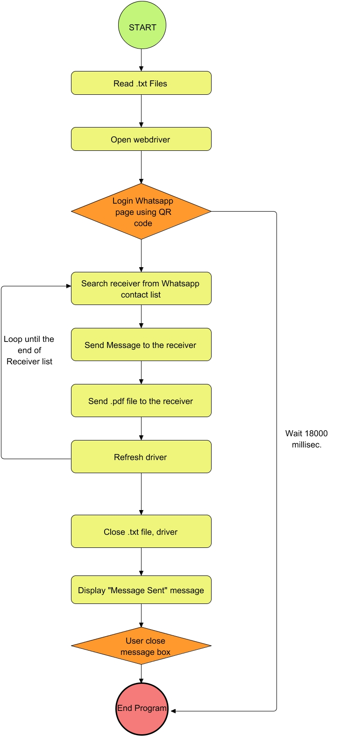

**PROCESS 1 (Read .txt file)**

1. Get the sender phone, receiver phones, messages, and .pdf file that are going to send.

**PROCESS 2 (Open web driver)**

1. Open Web driver and WhatsApp website

**POCESS 3 (Login WhatsApp page using QR code)**

1. Login sender account using QR code
2. If there is no log in within 18000 milli seconds, the program will terminate automatically.

**PROCESS 4 ,5, 6, 7**

1. These processes will loop until the end of the Receiver list.
2. Process 4: Search receiver from WhatsApp contact list.
3. Process 5: Send message to the receiver
4. Process 6: Send .pdf file to the receiver
5. Process 7: Refresh webpage(driver)

**PROCESS 8 (Close .txt file, driver)**

1. Close the used file after sending all the messages out.

**PROCESS 9 (Display “Message Sent” message)**

1. A message box will be displayed to inform user about the end of the process.

**PROCESS 10 (User close message box)**

1. User needs to close the message box manually to end the whole program.
2. Otherwise, the message box will be displayed, and the program is still running.
3. Python Codes
4. wa2u.py

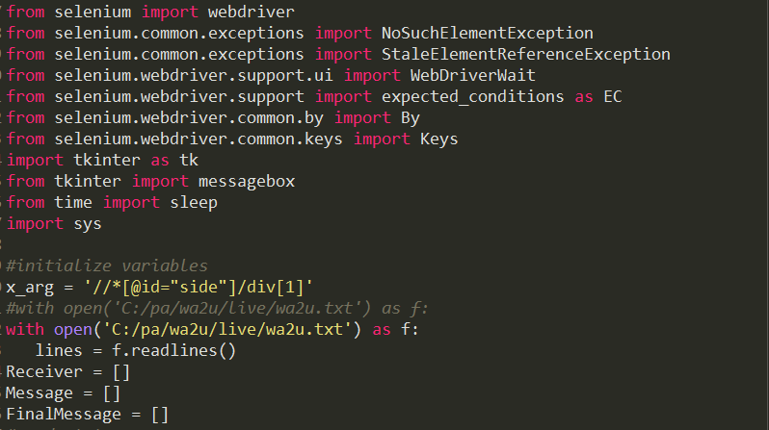

Figure 4.1: Import packages and initializing the variables

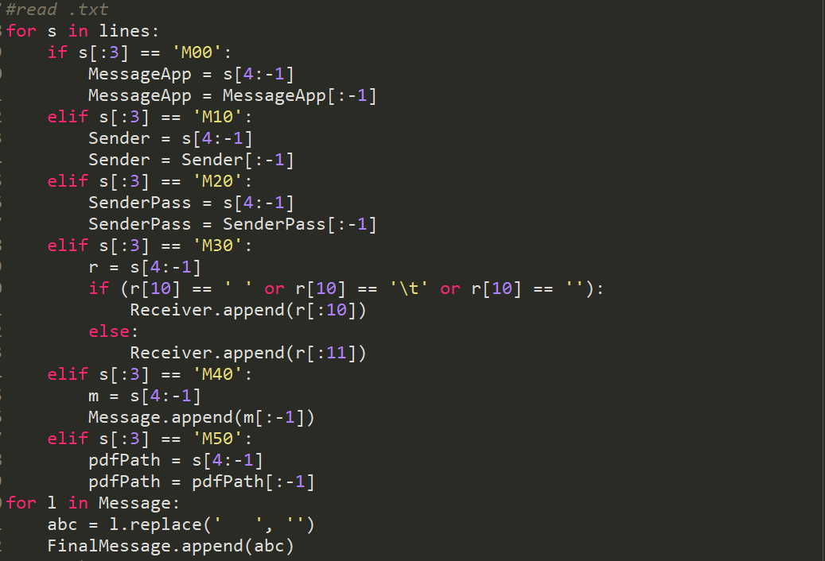

Figure 4.2: Reading the .txt file and save them

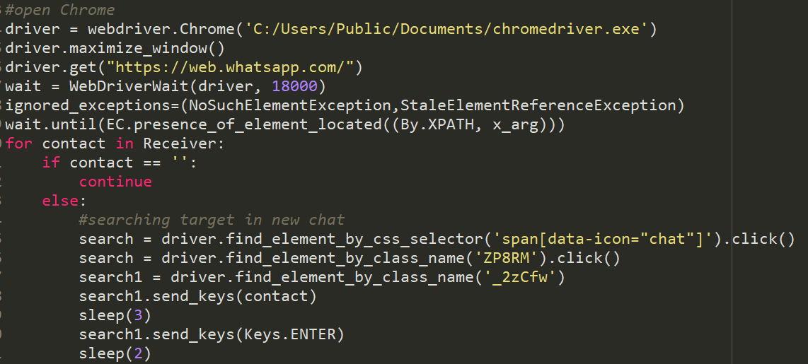

Figure 4.3: Open the chrome driver and WhatsApp Page

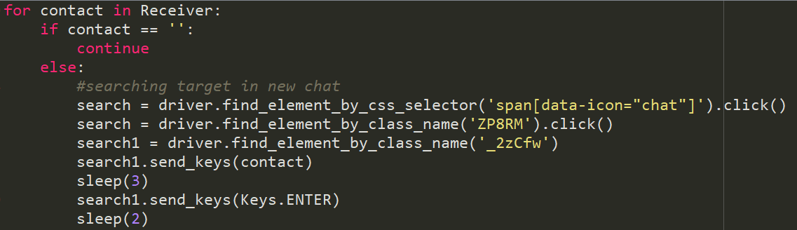

Figure 4.4: Start loop the receiver list, first is to search the target in contact list

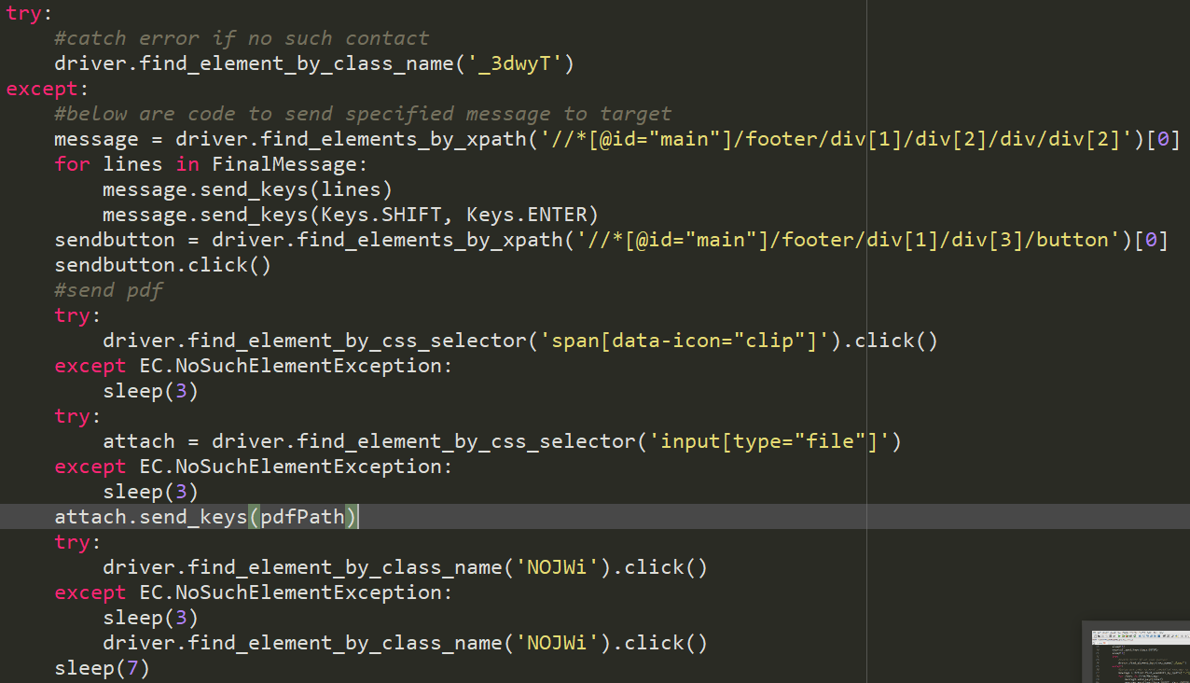

Figure 4.5: When target is searched, send the message and the .pdf file to the target.

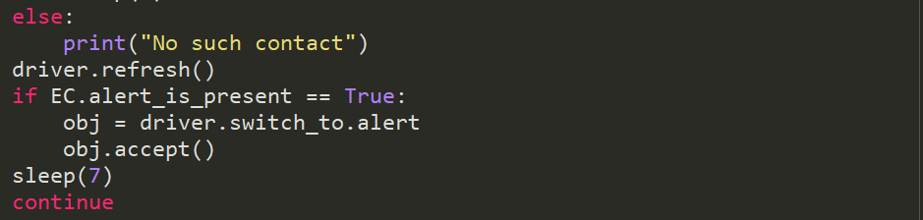

Figure 4.6: If target was not found, the process will be skipped to next receiver. Driver will be refreshed after sending process is done.

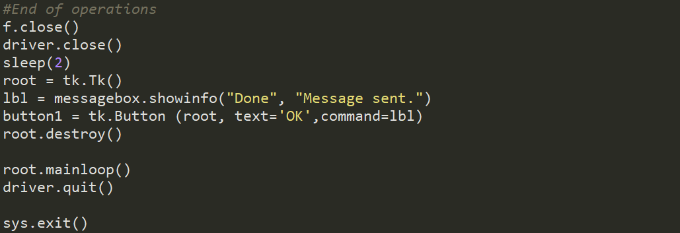

Figure 4.7: Closing file used and displaying the message box. Program end.